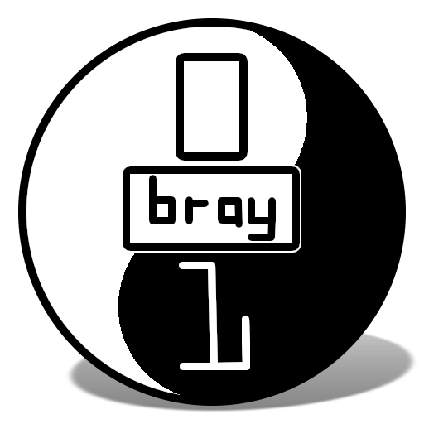
CoderDojo Bray
Writing games and animations with MIT Scratch

This lives online here: http://goo.gl/zn4XC

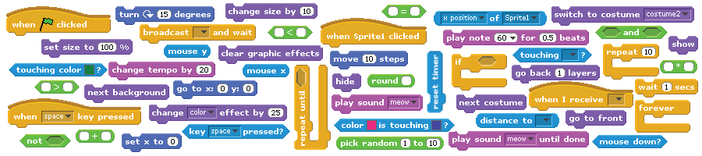

Developed by the ScratchEd team and released under a Creative Commons license.

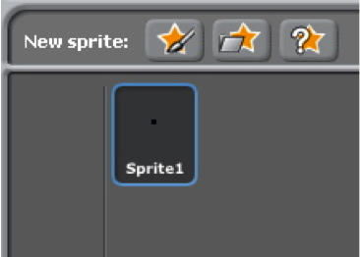
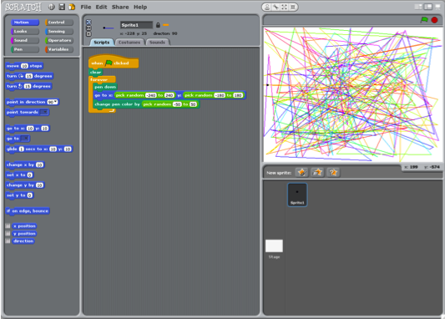
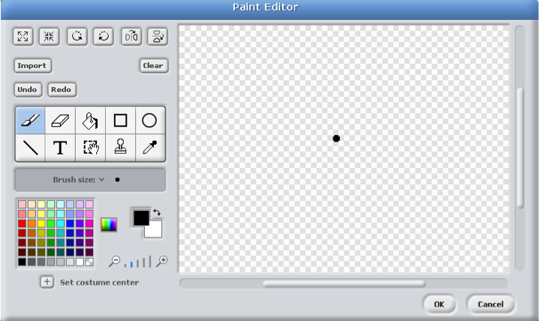
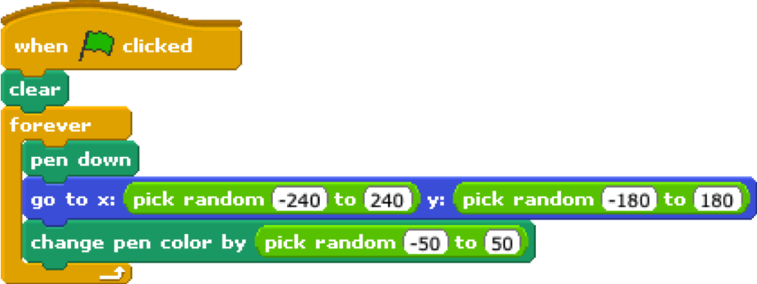
AUTOMATIC DRAWING
Make a project that draws something on its own.
create a sprite that
is just a small dot


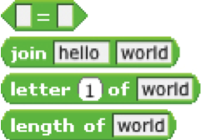

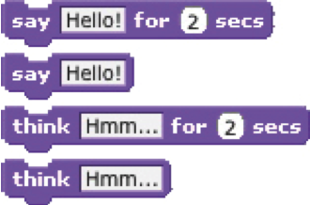
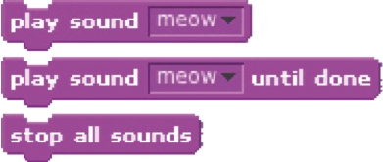
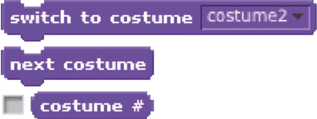
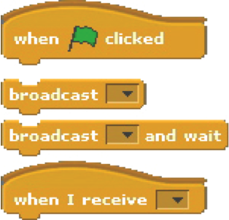
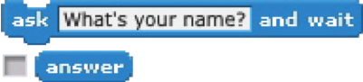
STORIES
Here are some blocks that can be useful in story-themed projects.
WAIT
Play recorded audio
Insert a pause
Have a speech or thought bubble
appear over a sprite
SOUNDS
VISIBILITY
COSTUMES
SAY/THINK
STRINGS
ASK
Get input to use in a project
Change the appearance of your sprite
Make a sprite appear or
disappear
Test, access, and change
words and sentences

COORDINATE
Synchronize actions between and
within sprites
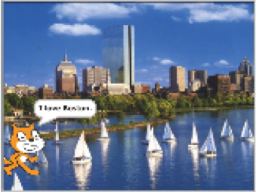
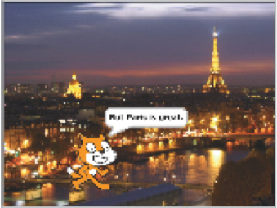
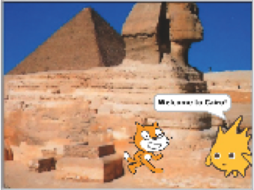
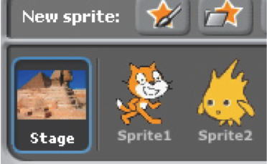
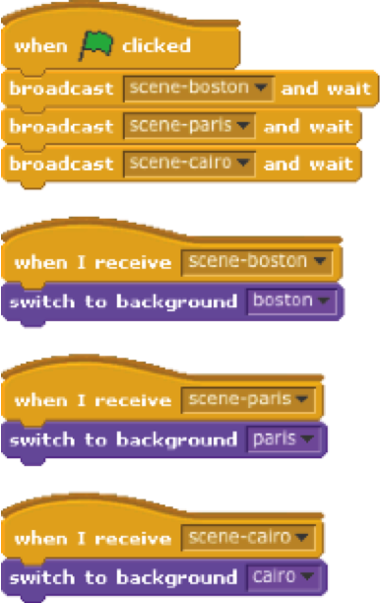
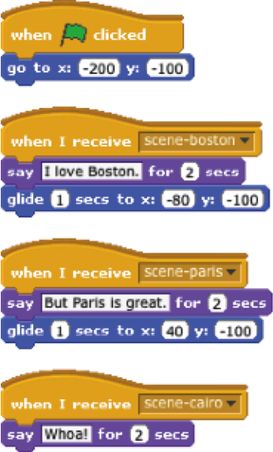
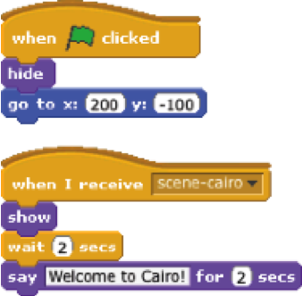
SCENES
add 3 background images

4 scripts
4 scripts
Use the broadcast and when I receive
blocks to create a multi-scene story.
2 scripts

BUG #1
Farooq wants his cat to rotate when he presses the space bar. But the cat isn’t moving! What’s going on?

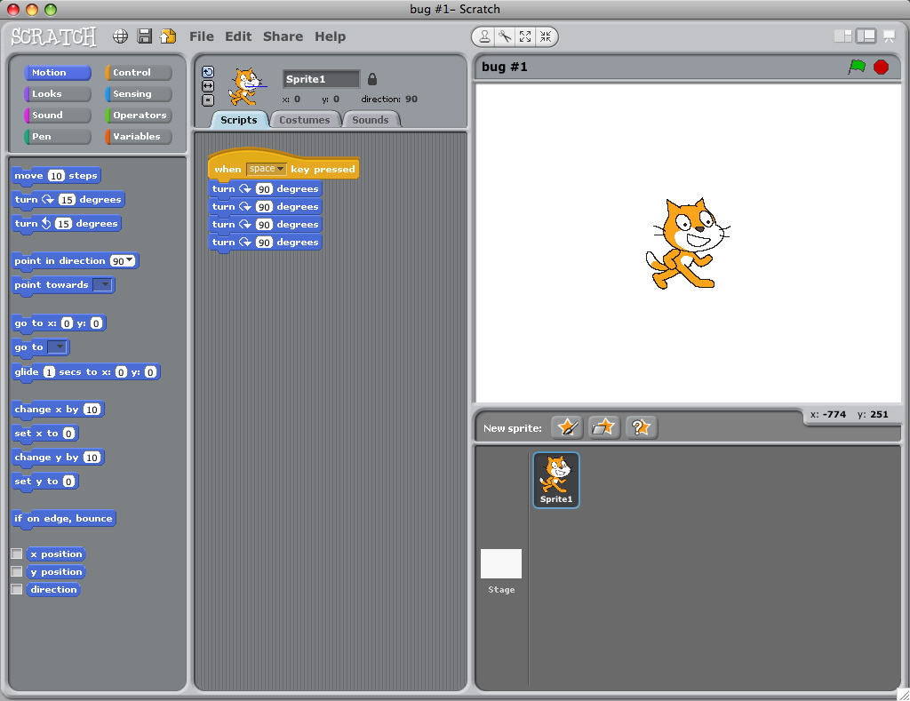

BUG #5
Nobuyuki wants his cat to jump up and down, and then move across the screen. But the cat’s hopping across the screen! What’s going on?

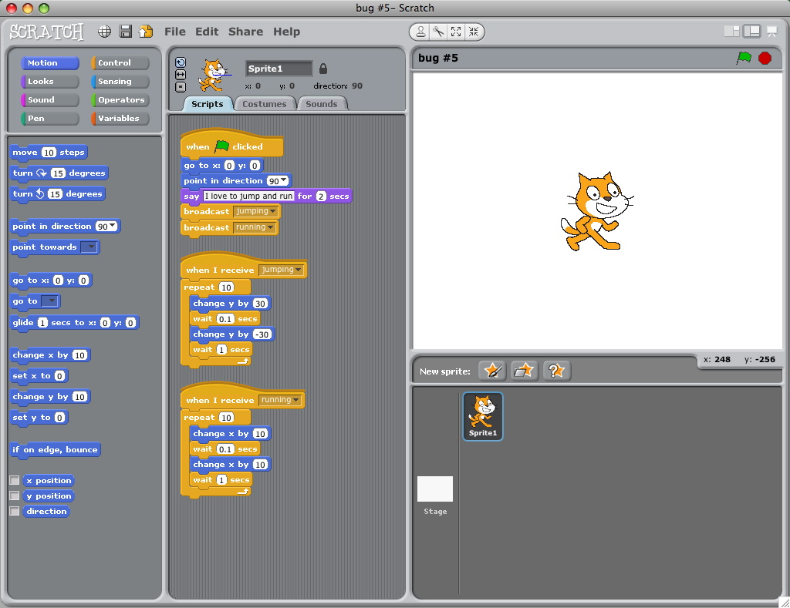

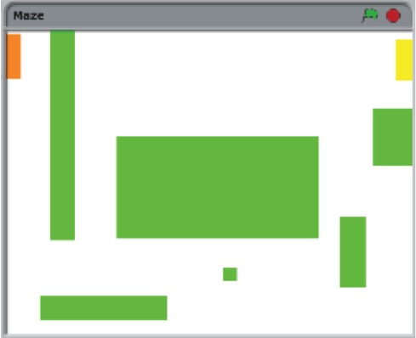
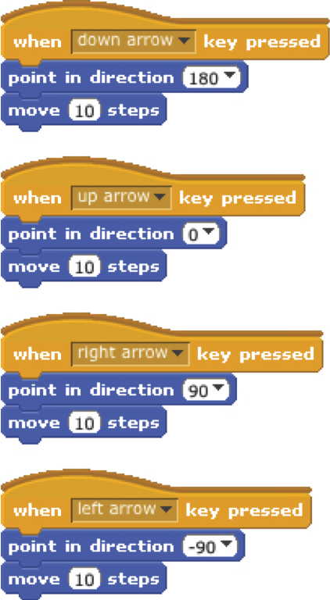
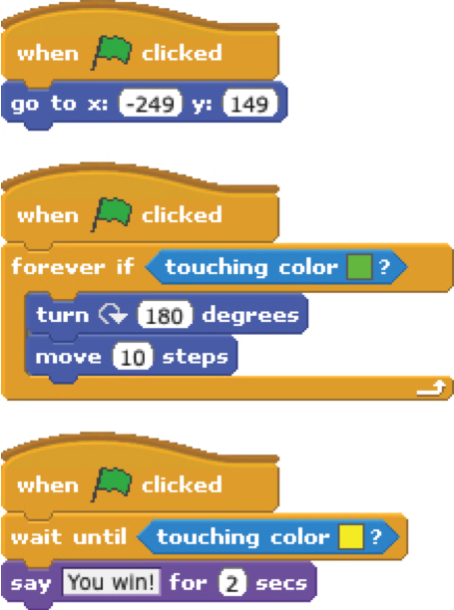
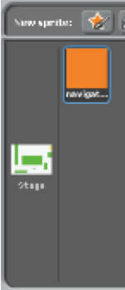
MAZE
Create a game where you get a sprite from the start to the end of a maze without touching the walls.

7 scripts total
have the sprite bounce off the green walls

move the sprite around
no scripts,
draw a maze-like
background with
colored walls and
a differently colored
end marker
players wins when sprite
reaches the yellow end marker
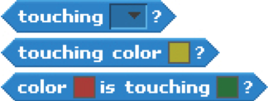
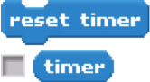

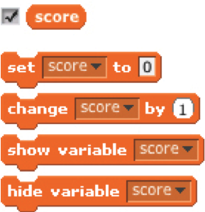
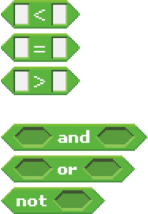
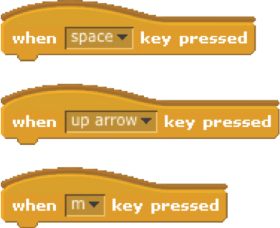
GAMES
Here are some blocks that can be useful in games.
TOUCHING
Get a computer-generated number
from within a specified range
See if two sprites are touching or
if a sprite is touching a color
Make a sprite appear or disappear
RANDOM
TIMING
STRINGS
VISIBILITY
KEY PRESS
COMPARE
VARIABLES
Store a number or string in a
container to access later
Test, access, and change words
and sentences
Have the computer keep track of
time for you
Make a sprite respond when different keys are pressed
Compare values to help make
decisions within your game
Plan for my project

Name:

A description of the project that I want to create:
The steps I will take to develop my project:
The resources (e.g. people, sample projects) I already have to develop my project:
The resources (e.g. people, sample projects) I might need to develop my project:

Sketches of my project

Name:

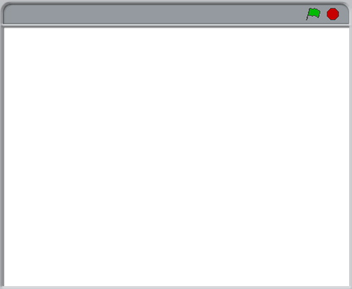
What’s happening?  What are the important elements? |  | What’s happening?  What are the important elements?
What’s happening?  What are the important elements? |  | What’s happening?  What are the important elements?

Developed by the ScratchEd team and released under a Creative Commons license.

